Documented Design

Data

|  |  |  |
| --- | --- | --- |
| Key Variables | Variable Type | What it is used for |
| Board | TArray – 8x8 array of integer | Used by main methods and other global variables to store the positions of checkers on the board. |
| CBoard | TBoard – object class | Used by main methods to initialise the array, at the beginning of a game, also used to determine which players counter is at a position on the board. |
| CMove | TMove – object class | Used to move checkers on the board, check if it is a legal move, and generate all legal moves for a player. |
| CAI | TAI – object class | Used to find the next move for the opponent. |

Other data structures

TArrayList – an array of undefined length that stores TArray.

TArray – an 8x8 array of integers.

TCoordinate – an array of length 2 that stores integers.

TCoordArray – an array of undefined length that stores TCoordinate.

Class-Relationship diagram

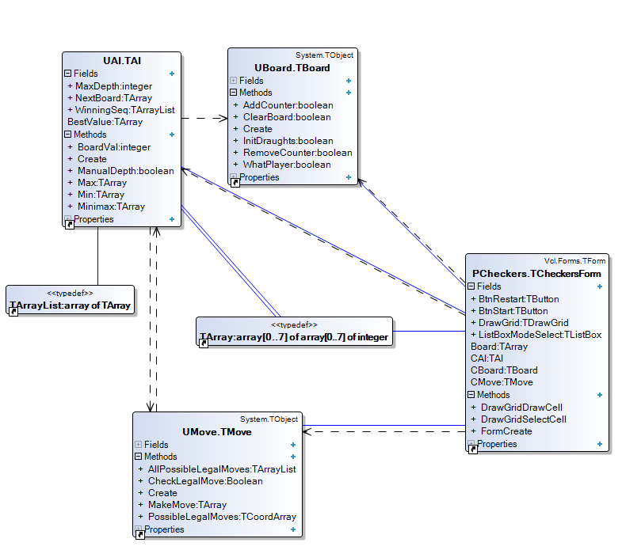

Hierarchy chart

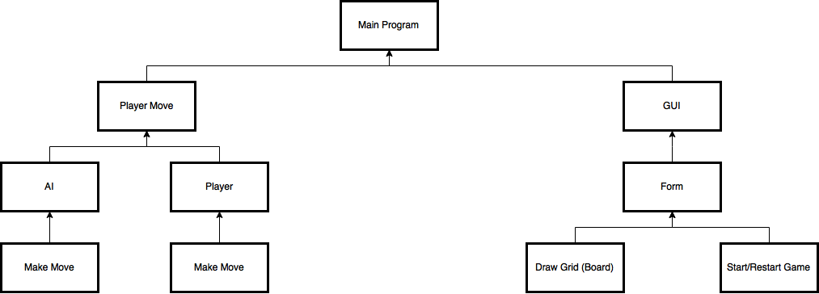

Algorithms

Minimax – UAI

function Minimax(board, depth, maxPlayer) {

if depth ≠ 0 then

listOfMoves ← allPossibleLegalMoves

if maxPlayer then

for I ← low(listOfMoves) to high(listOfMoves) do

BestValue ← -∞

BestValue ← Max(BestValue, I)

result ← BestValue

else

for I ← low(listOfMoves) to high(listOfMoves) do

BestValue ← ∞

BestValue ← Min(BestValue, I)

result ← BestValue

}

CheckLegalMove – Umove

InitArray - UBoard